INSTALLATION



\*this will be in the first page of the brochure with a picture

THE NATIONWIDE RESOURCE FOR PREMIUM “TURN KEY” WINDOW, DOOR, GLASS PRODUCT, AND ALL FENESTRATION INSTALLATION SERVICES FROM CONCEPTION TO APPLICATION TO MAINTENANCE.

1.PRE CONTRUCTION-PLANING

The Sequel team prides itself on our involvement in site evaluations before our scopes of work commence. Our main goal is to answer as many questions as possible on the placement of windows and doors in three dimensions, equipment needed and opening sizes / placement before installation team arrive. We do this through a combination of verifying control lines and center marks placed by others, examining architectural and shop drawings with the general contractor, making story sticks for the entire project, and talking through the installation processes including how installed units will be finished off. When the Sequel installation team arrives to start performing our scopes of work, a game plan is already laid out to minimize error and expediate our process.

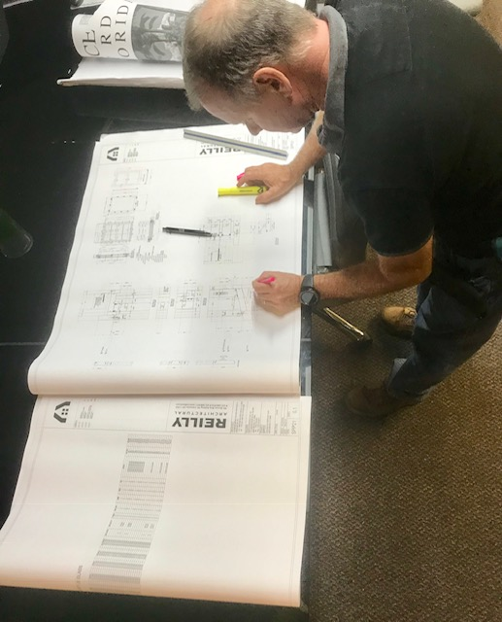

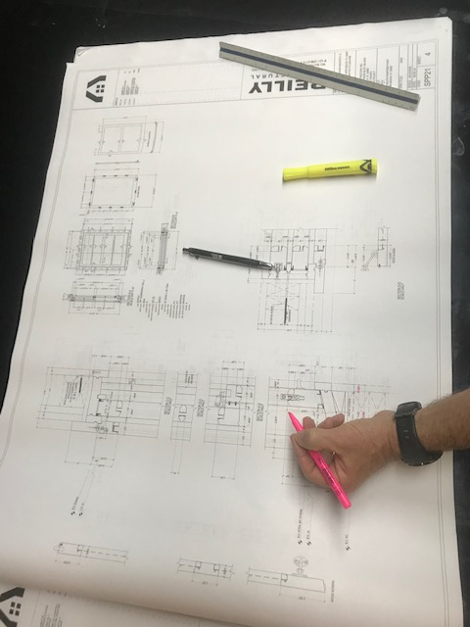

2. BUCKING

Depending on the structure of the building wood bucking is an integral part of window and door installation. With our home base in South Florida, achieving highly precise rough openings is an absolute necessity with maximum shim spaces regularly being held to ¼”. Our standard is to use treated or borate lumber structurally fastened using ¼” stainless steel tapcons every 12” to meet hurricane building codes. We also add two lines of compatible sealant under the buck as sub-caulk and a the same sealant as face caulk (cove joint between the buck and masonry on the exterior) after the buck is installed.

With the information collected from the pre-construction planning process, lumber is planed and milled on site in order to achieve near perfect openings at correct heights and centers within required shim space.

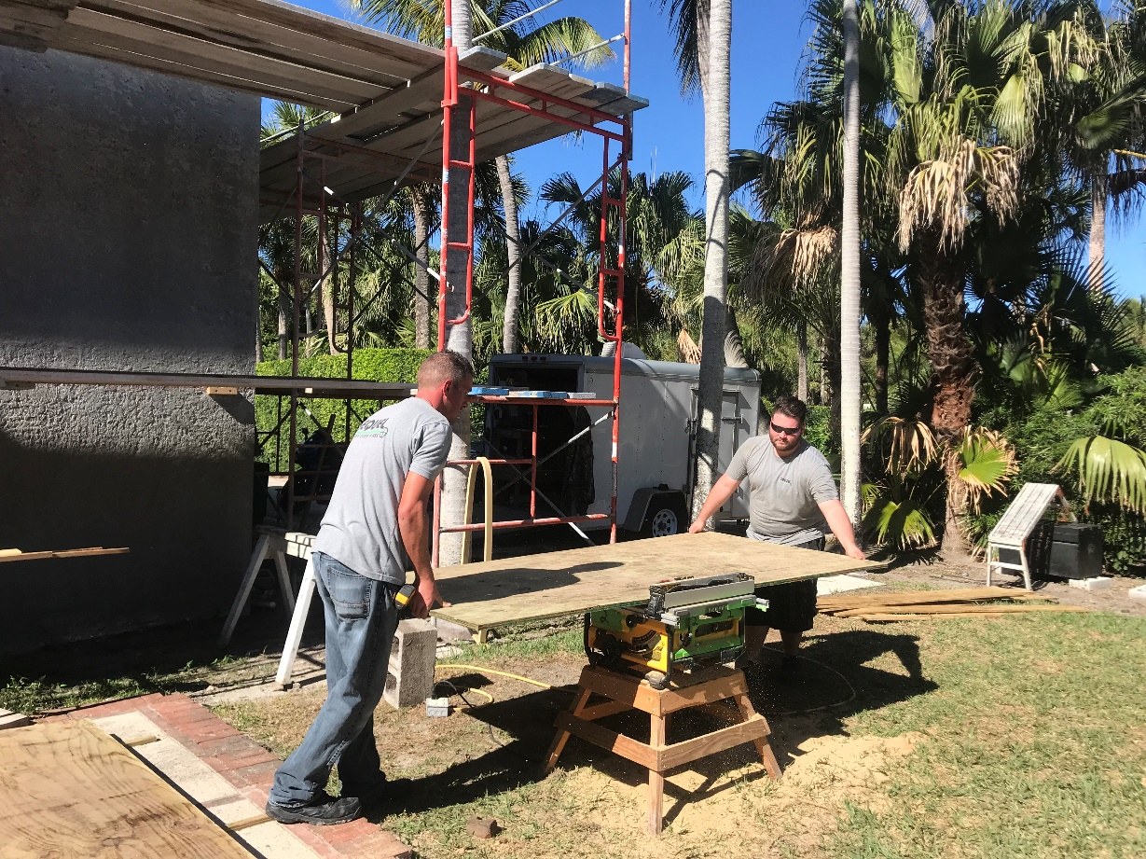

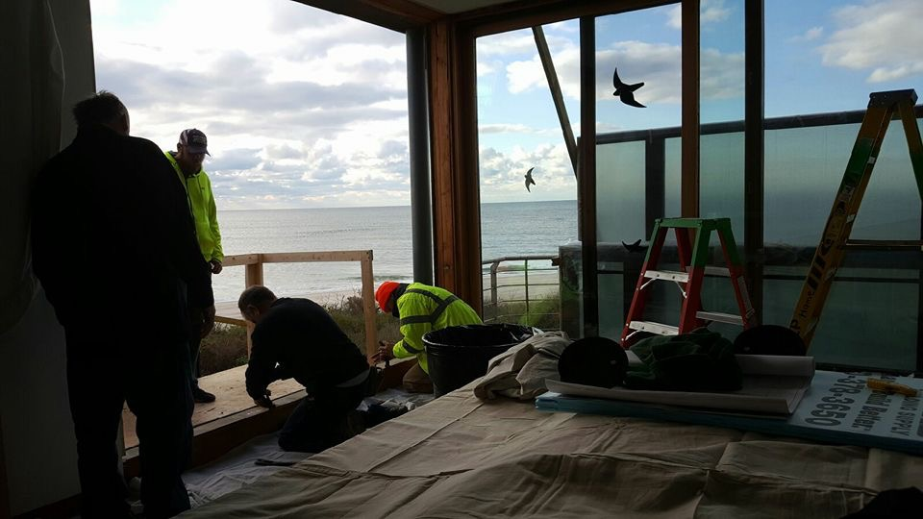

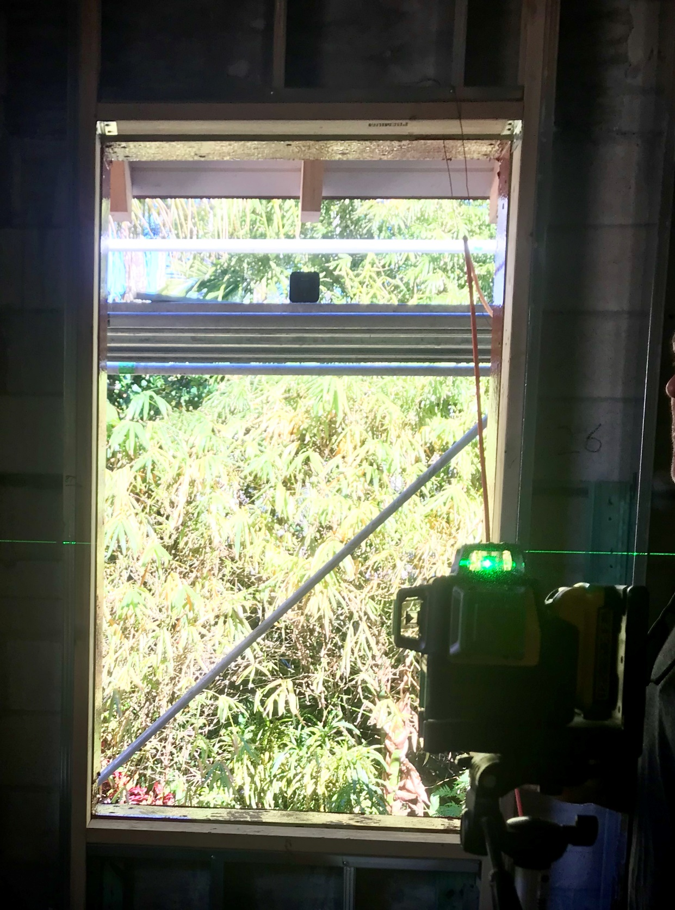

3. WATERPROOFING MEMBRANES

Waterproofing membranes differ greatly based on location, environment, and type of construction. We don’t promote anyone brand over another, but due to their popularity we have great experience with Prosoco R-Guard, Blue barrier, Dow-Corning, and ZIPs Systems. We recognize that there are many products, but the main difference between their performance is usually proper application and product compatibility. Dry, clean openings are non-negotiable at this point of construction and using one product line throughout is greatly preferred.

When Sequel is responsible for the waterproofing scope, we can better control the timeline of a project so that membranes are not apply to soon to get damage by the sun, and not too late to be holding up other scopes of work.

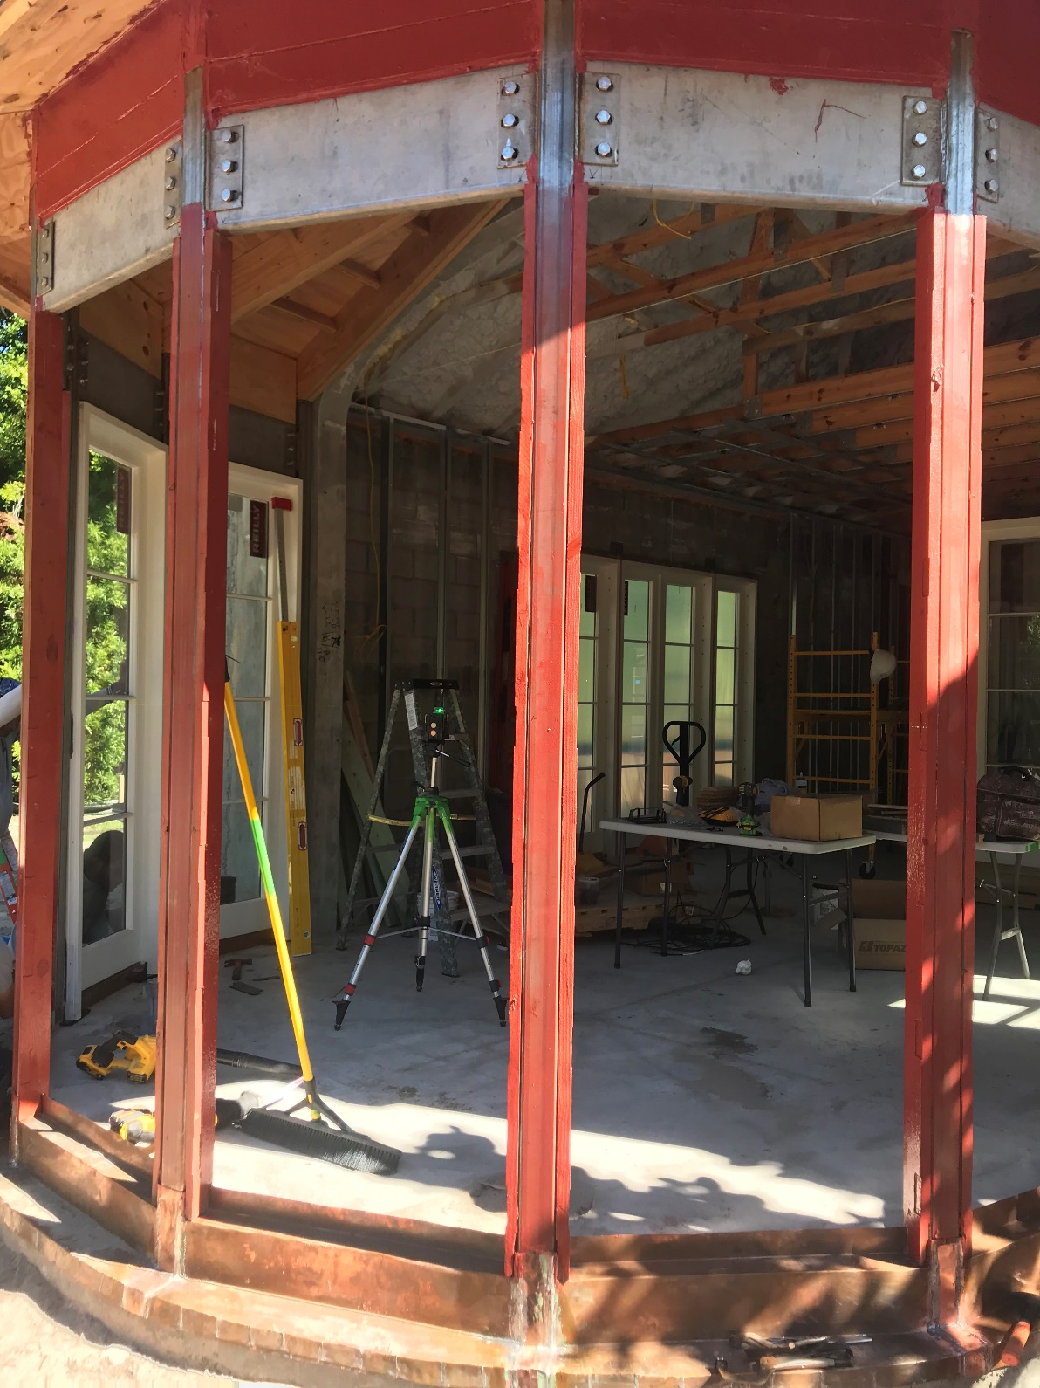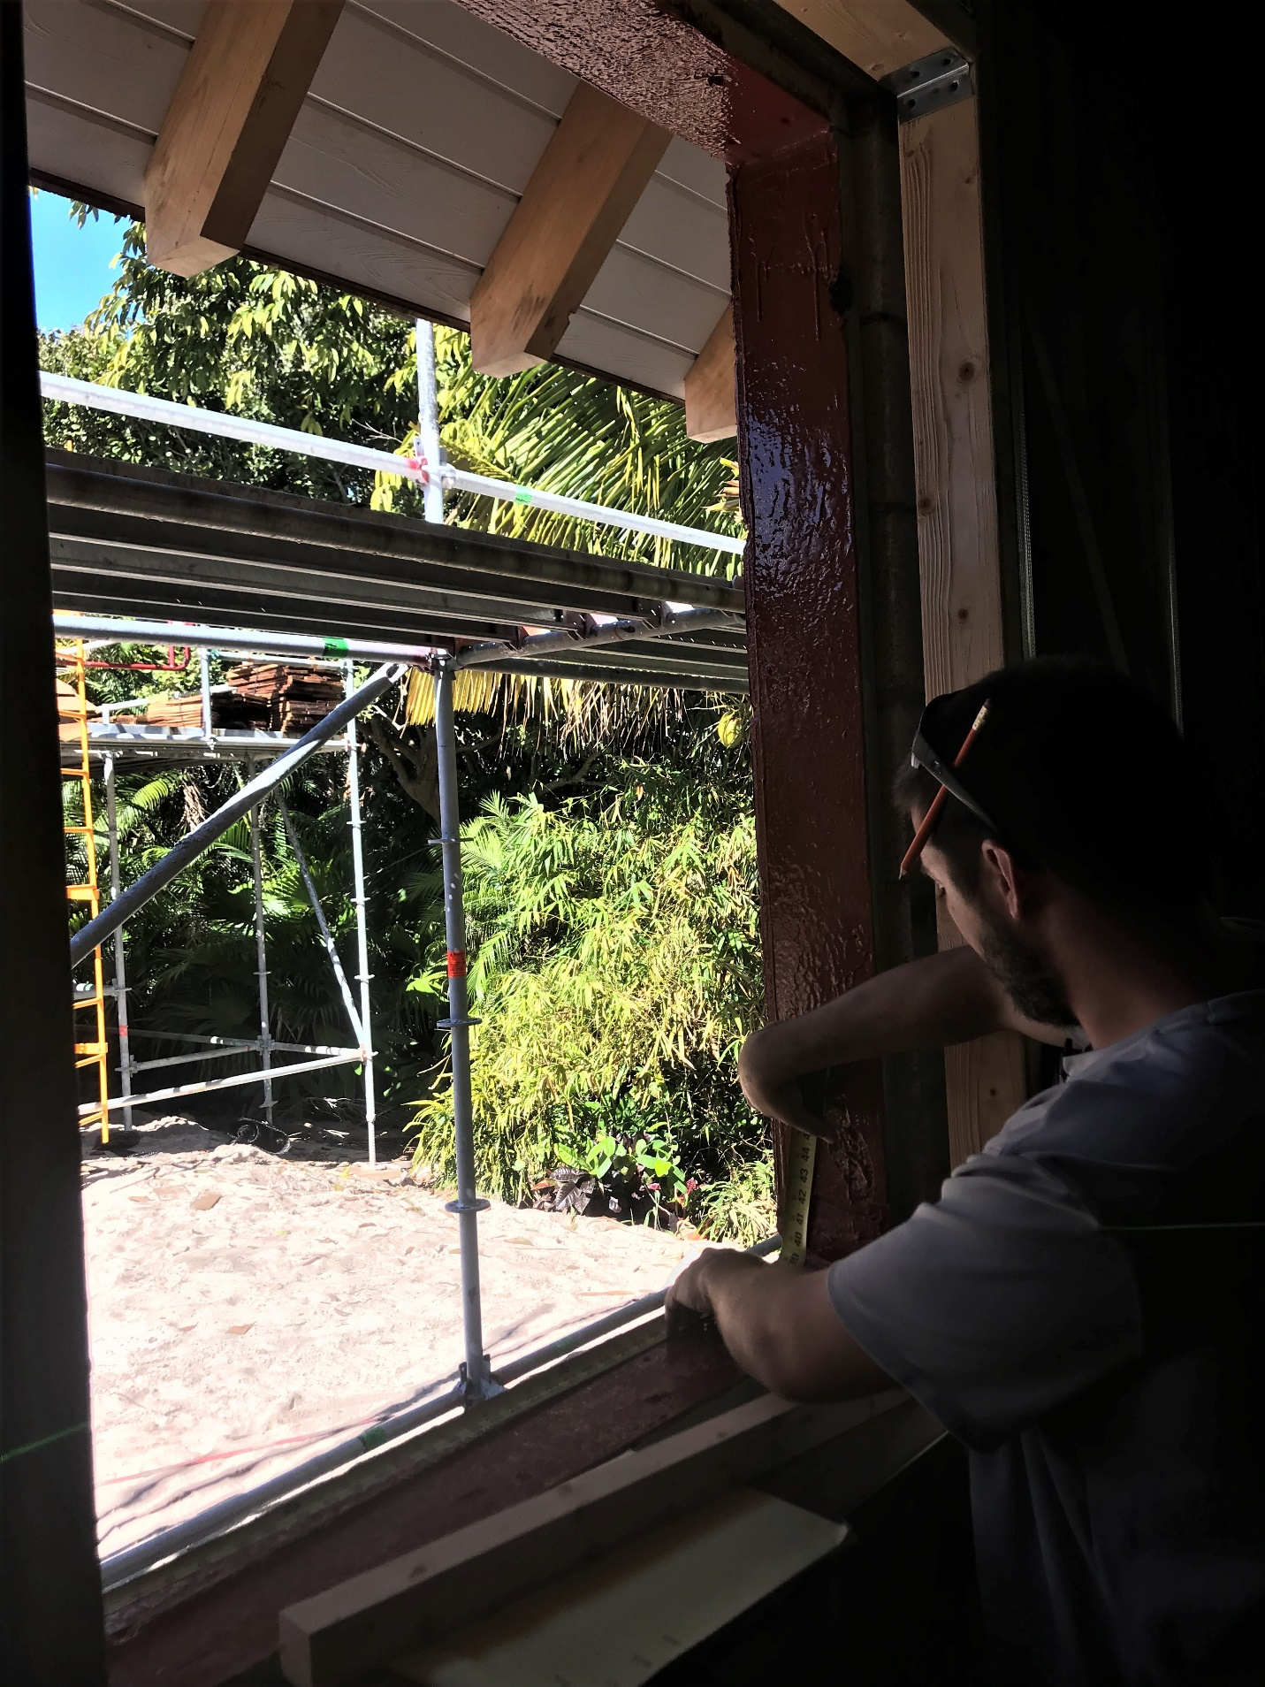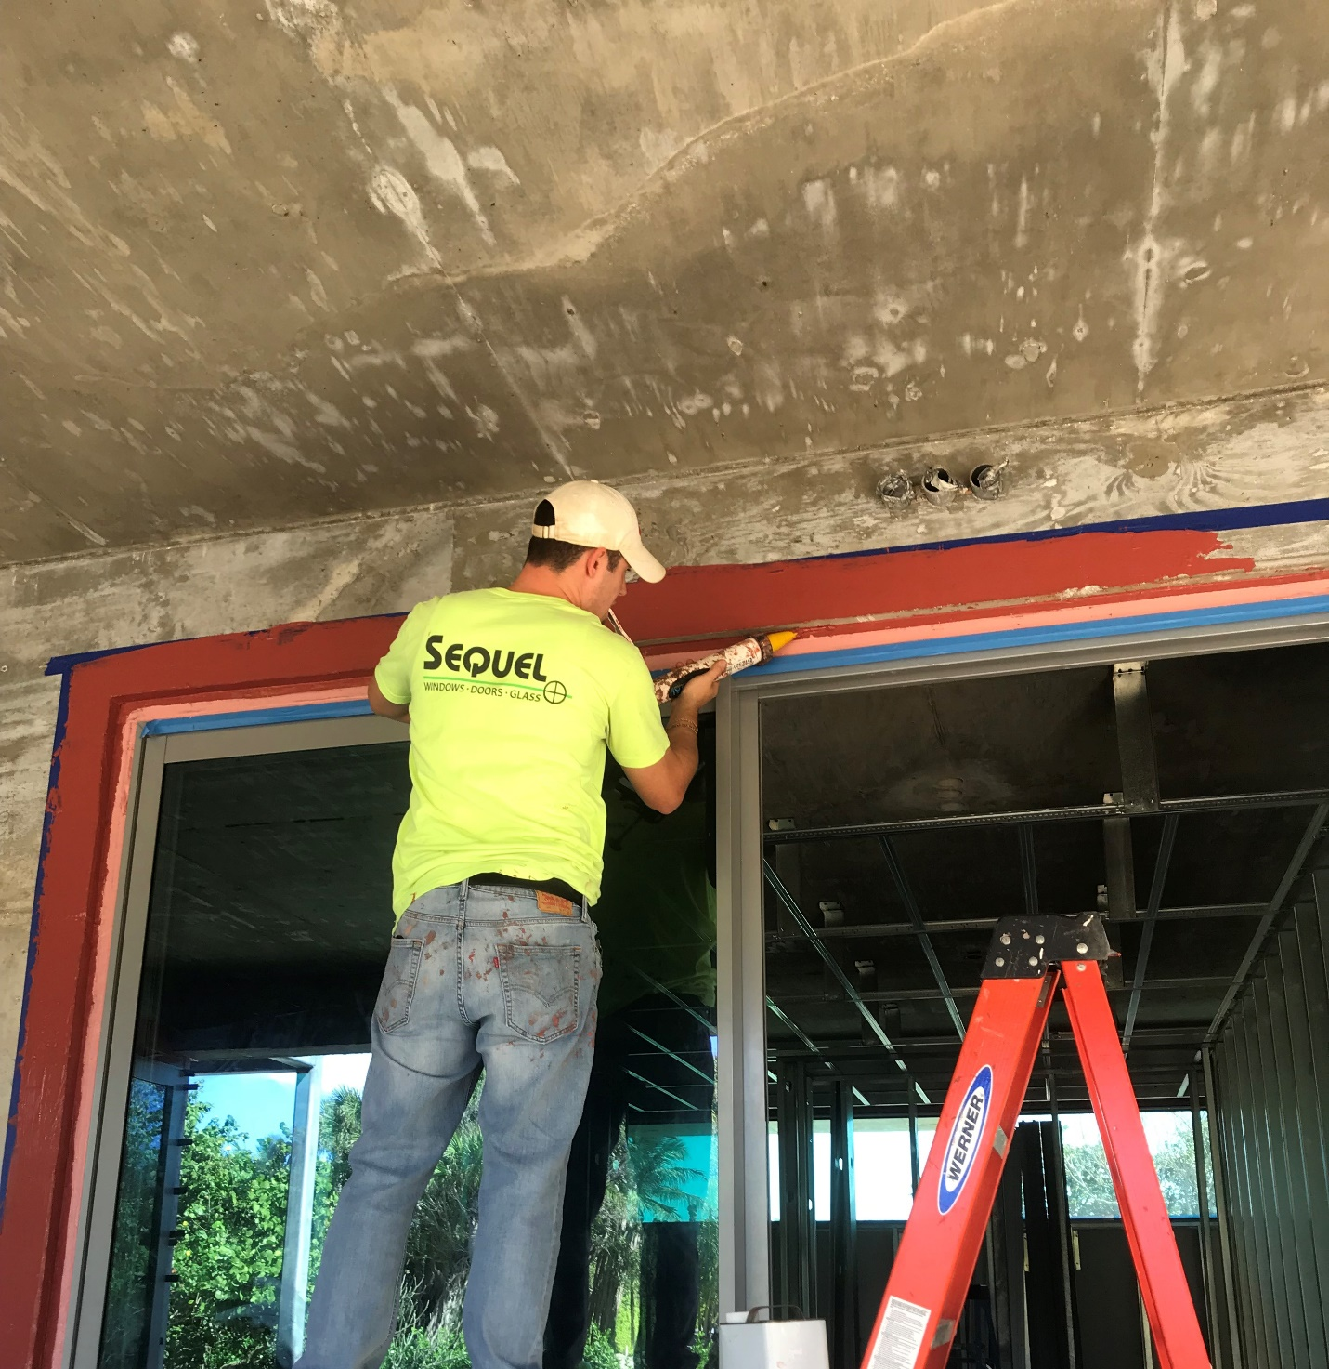

4. PANS

In the luxury construction market, window and door pans are a common addition to the overall waterproofing plan. With the information collected in the pre-construction planning, pans are designed and made on site for each opening to achieve top performance and fit with the finish details. Our standard pan is a simple 2 bend copper with solder corners and seams. We also can add additional materials such as lath or make pans with other material as well. Again, with Sequel controlling this scope of work, timelines can better be controlled so that pans are not installed too soon which can lead to damage, and installation teams are not waiting on pans to trickle in.

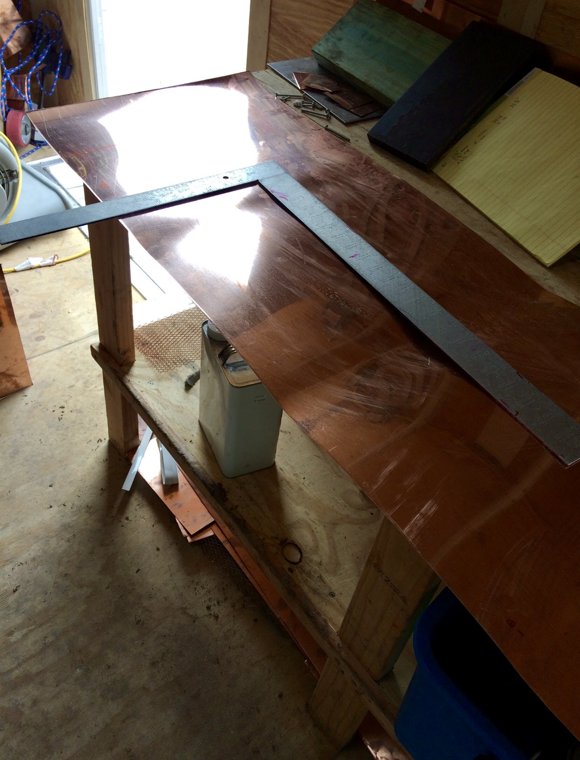

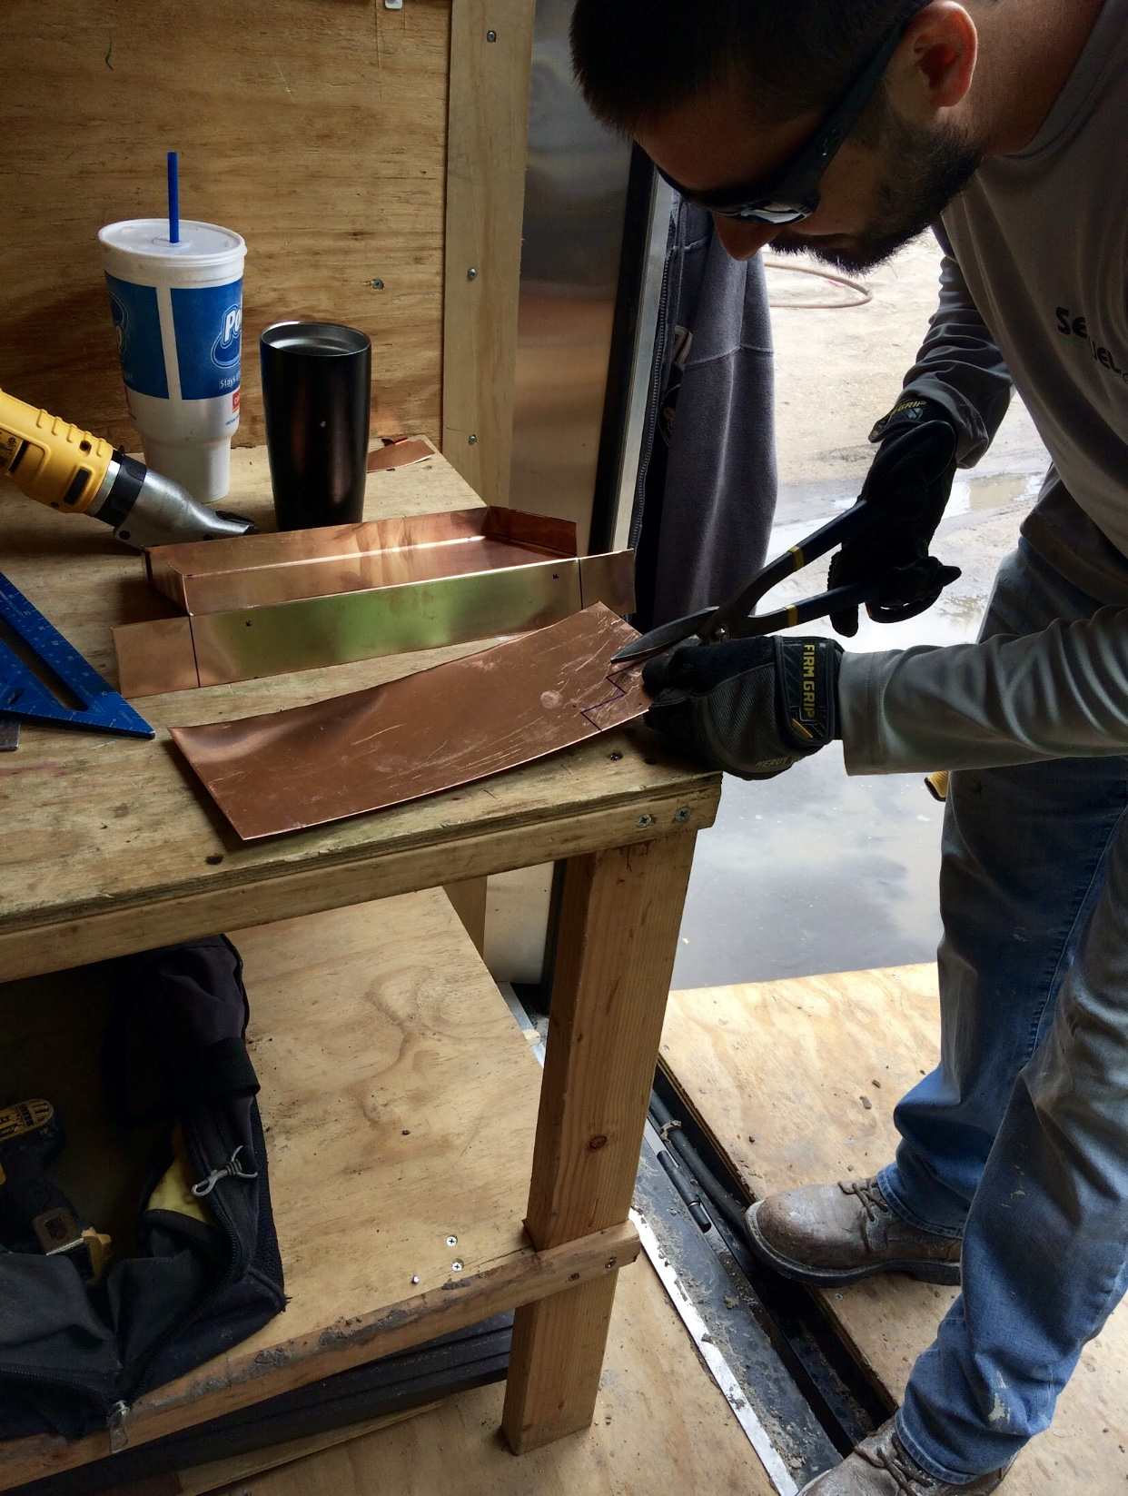

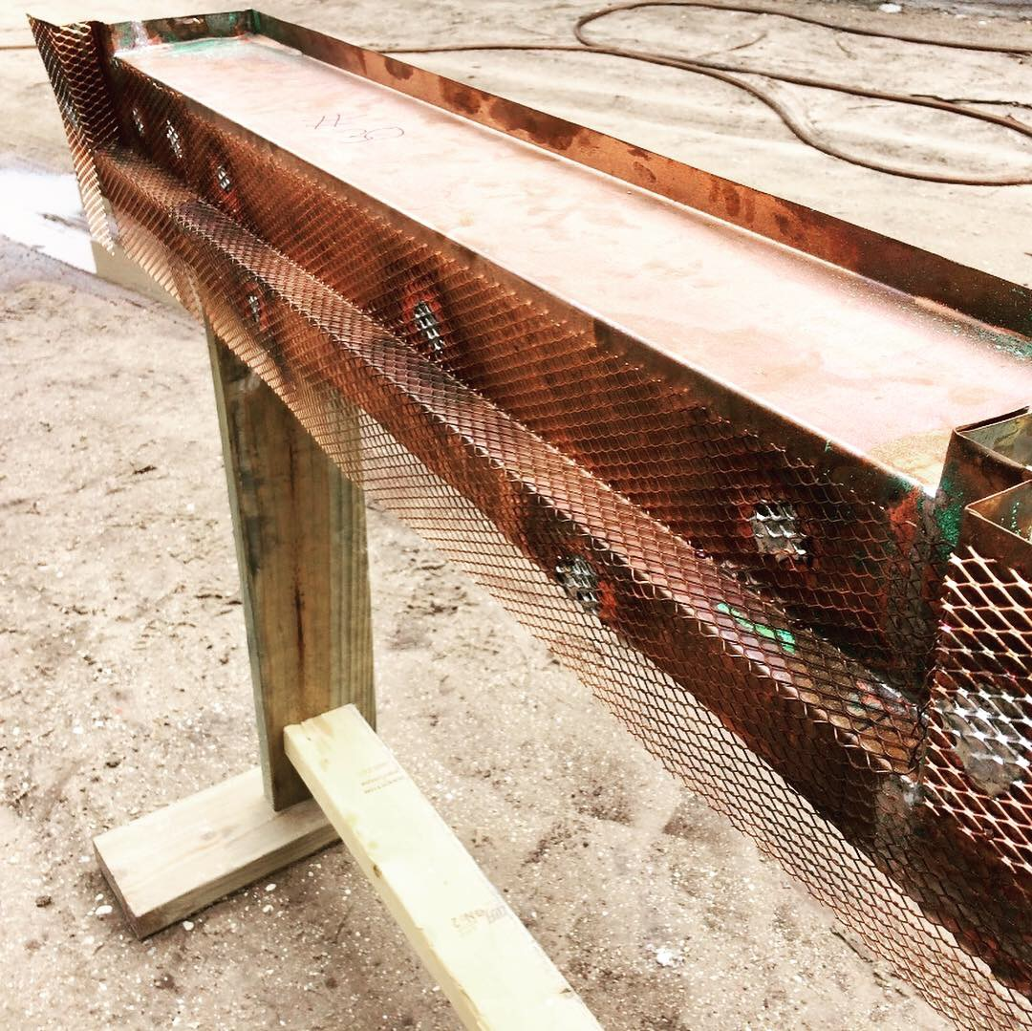

5. INSTALLATION

5.1 DELIVERY

Working with different manufacturers have shown us the many delivery methods of getting products on site. Shipping techniques include individual boxing, crating, and loose shipping in semi-trailers. Getting product on site and staged in place can prove challenging in many situations, which is why material handling equipment and the propriety tools and methods regularly used by our teams are so important to ensure safe and secure handling. Telescopic forklifts, cranes, a multitude of dollies, and accessory racks and braces coupled with a strong culture of product care are the main key

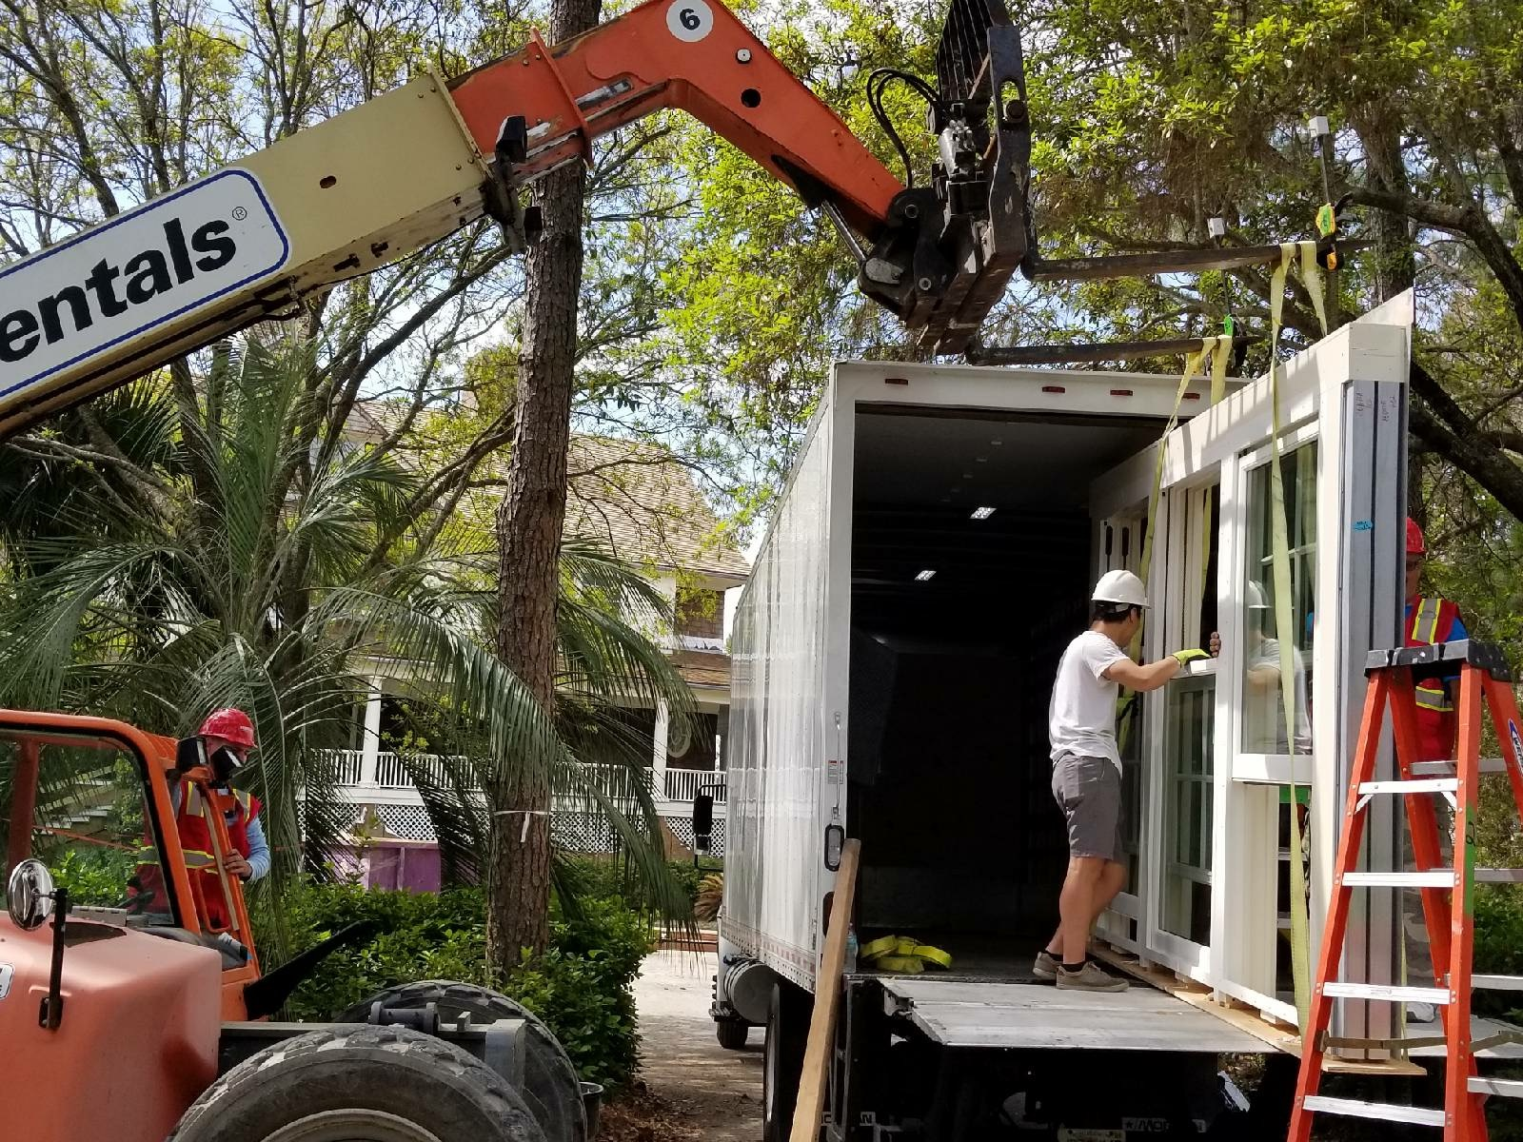

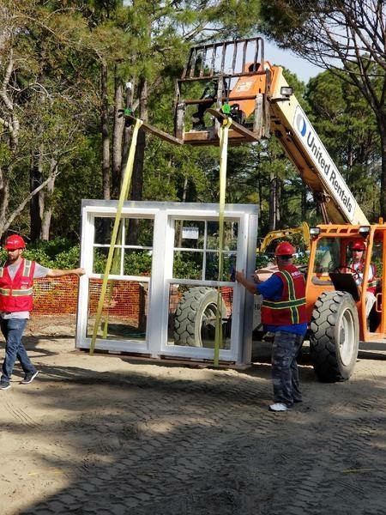

5.2 Depending on product installation requirements, units must be prep a number of ways prior to installation. Great care is taking while pre-drilling, counter sinking, counter boring or attaching clips, some building departments also required inspections for structural attached mounted clips.

With certain materials such as mahogany, any penetration expose to the weather can cause bleeding and damage, which is why all hole are sealed.

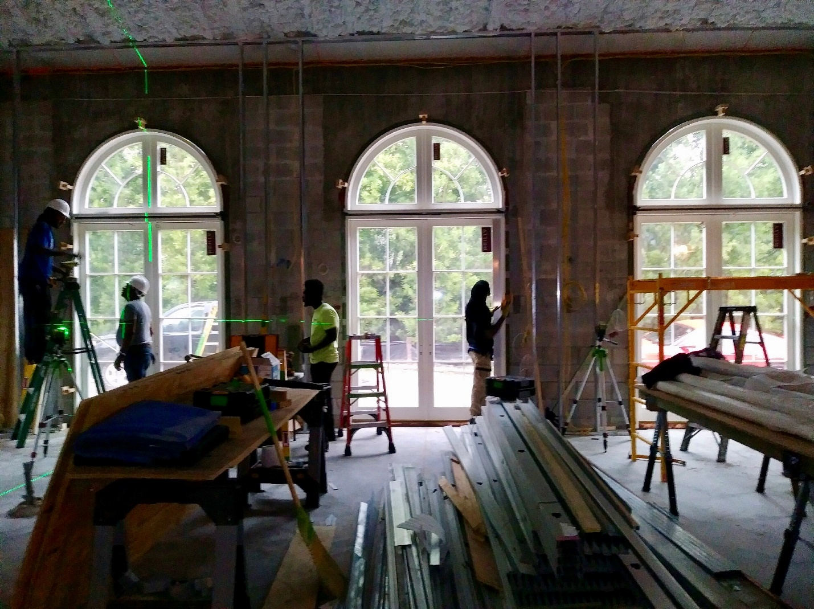

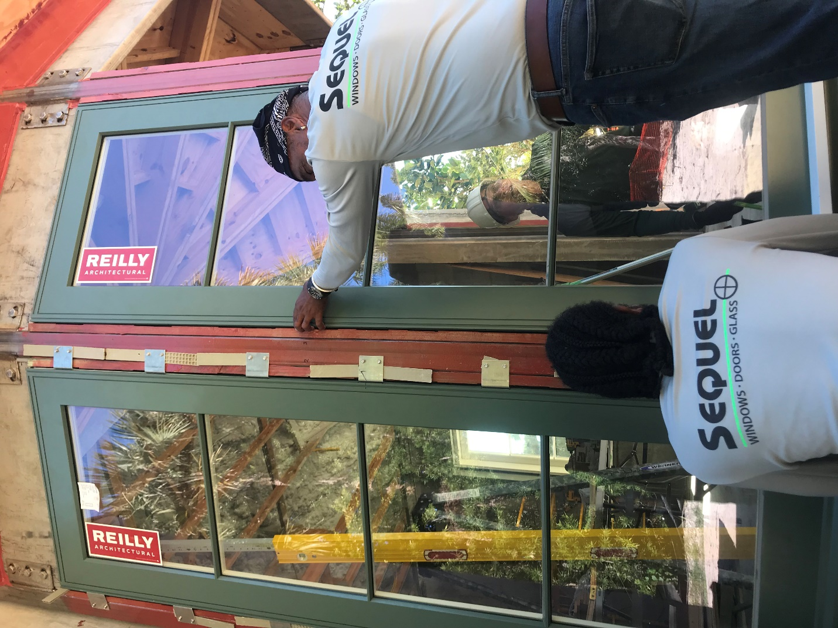

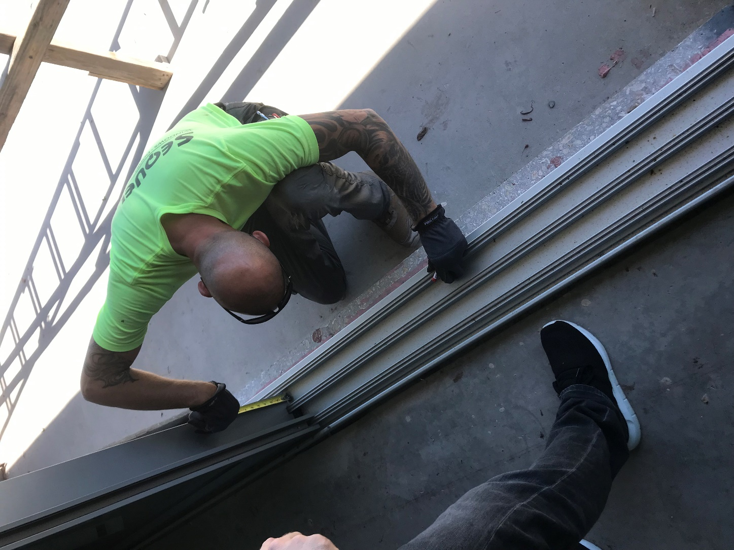

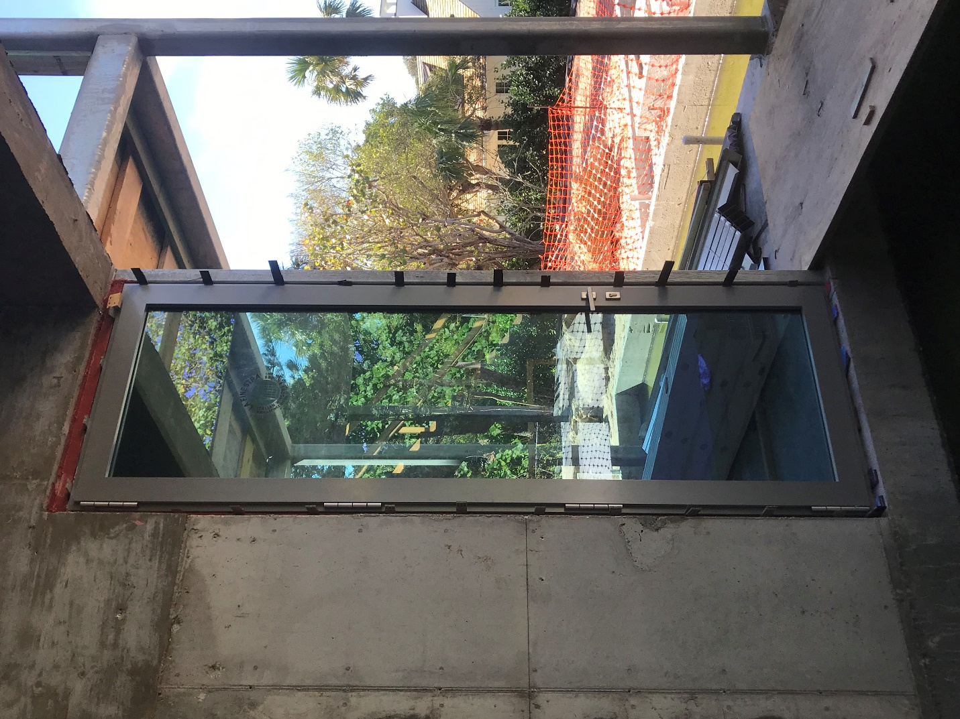

6. CAULK

Similar to waterproofing membranes there are many great caulking products and application methods that defer base in construction and environment. When working on choosing a caulking product, compatibility is our main concern.

The last variable will be the window material and frame type, but regardless the proper application of the materials used will determinate the longevity of the work.

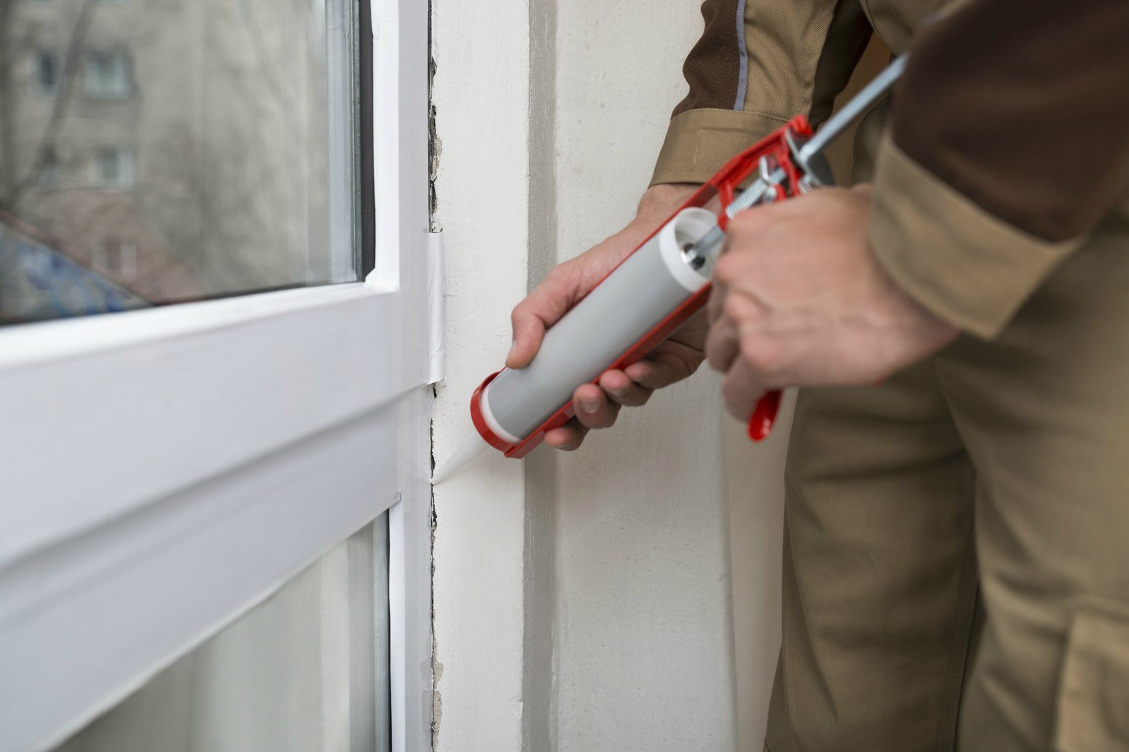

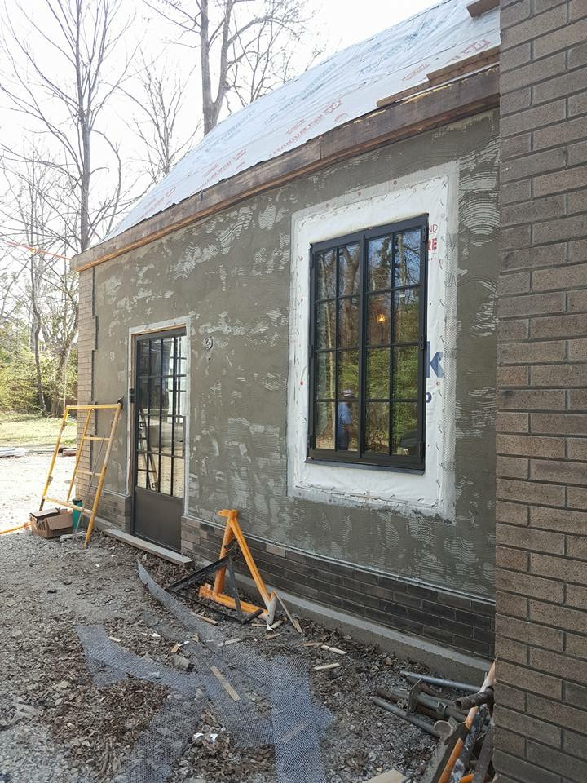

7. TRIM

Many manufacturers may include different “trim work components”. We regularly install items sent loose such as brickmold, extension jambs, shade/screen pockets, sill noses, etc. The key component is to know the material and environment you are working with, for example, when installing mahogany brickmold, all cut ends must be seal and installation must be done with stainless steel nails and a comparable caulking for back-beads.

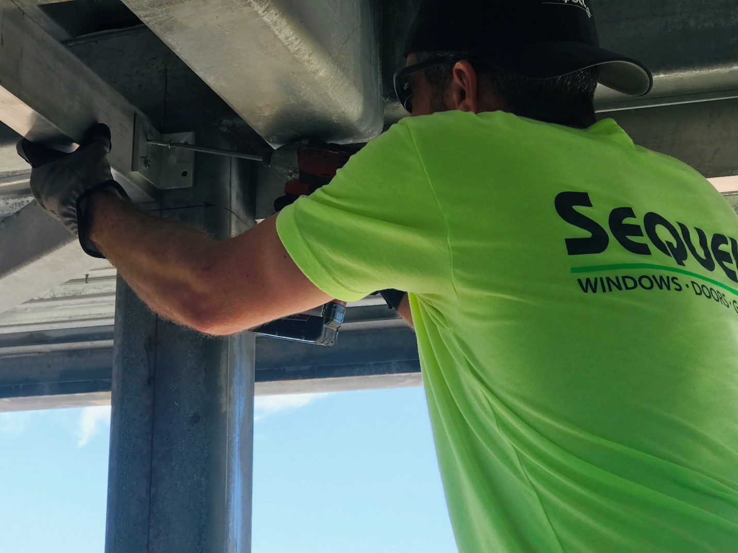

8. RETRO

Replacing windows and doors in luxury historical homes is a big part of our background. The two keys to egret replacement job is protection of the home and preservation of the interior and exterior finishes. We use a combination of drop clothes, paper and plastic sheeting and YAK walls (plastic walls) to protect and incapsulate the areas being work, then we use a surgical removal method so that interior trim and exterior finish is left undisturbed.



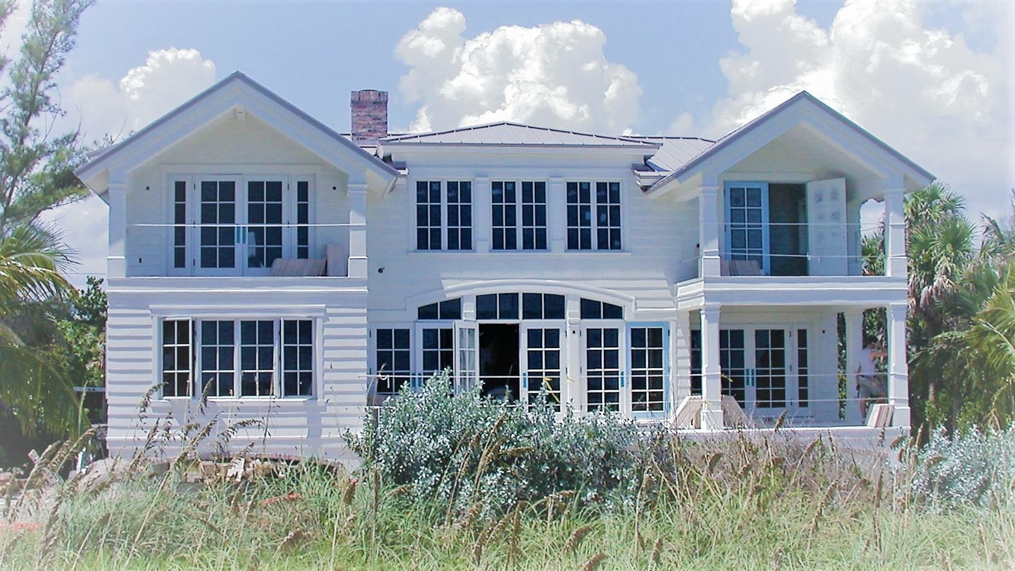

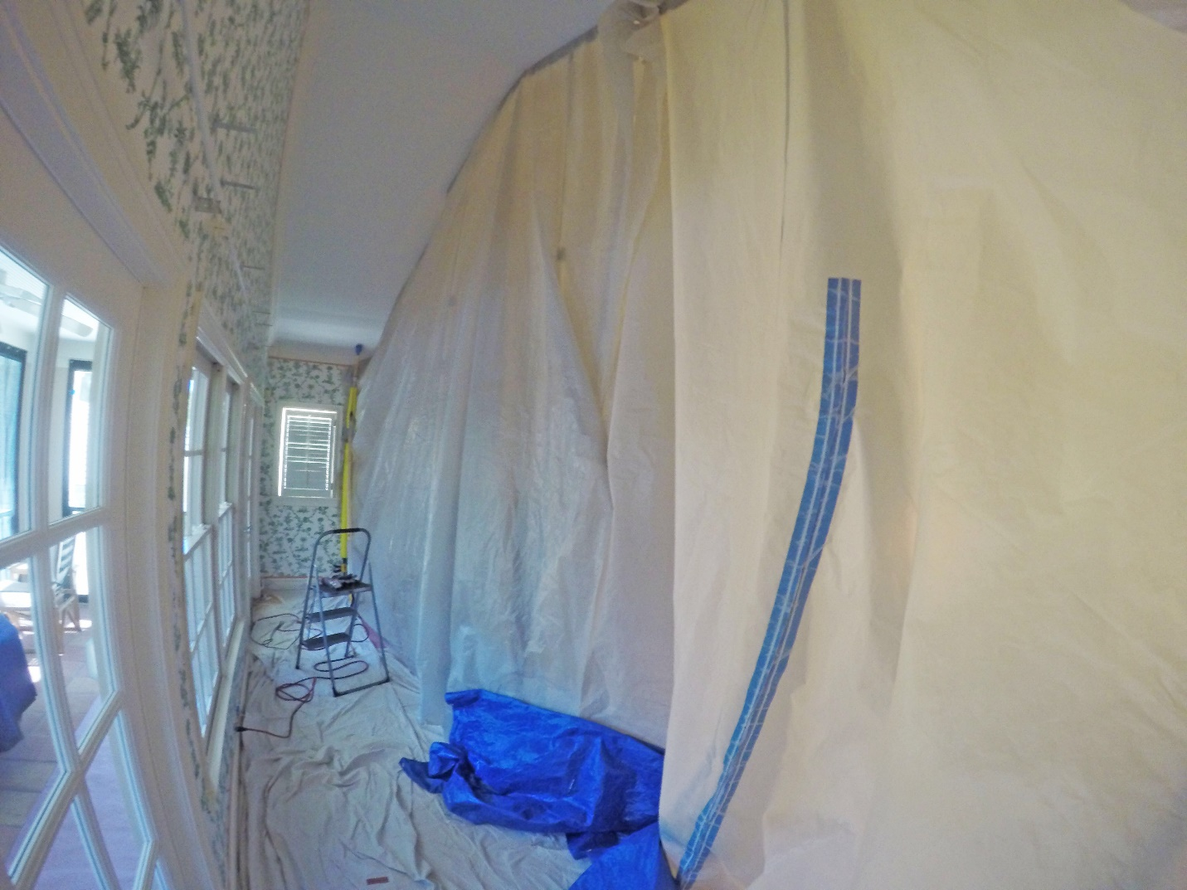

9. SERVICE

We have our own service team to perform 4 different types of work. 1. Perform factory and warranty type service for manufacturers usually around the time of a CO or within a warranty period. 2. Schedule maintenance to keep units in proper shape and maintain warranty requirements with records kept. 3. Final walkthroughs on or own projects after installations have been completed. 4. General service post warranty or outside warranty such as replacement of operating mechanisms., re-glazing of units, adjustments for operation, etc.

We represent for service ourselves, window manufacturers, builders, general contractors and the end user depending on the time and type of service needed.

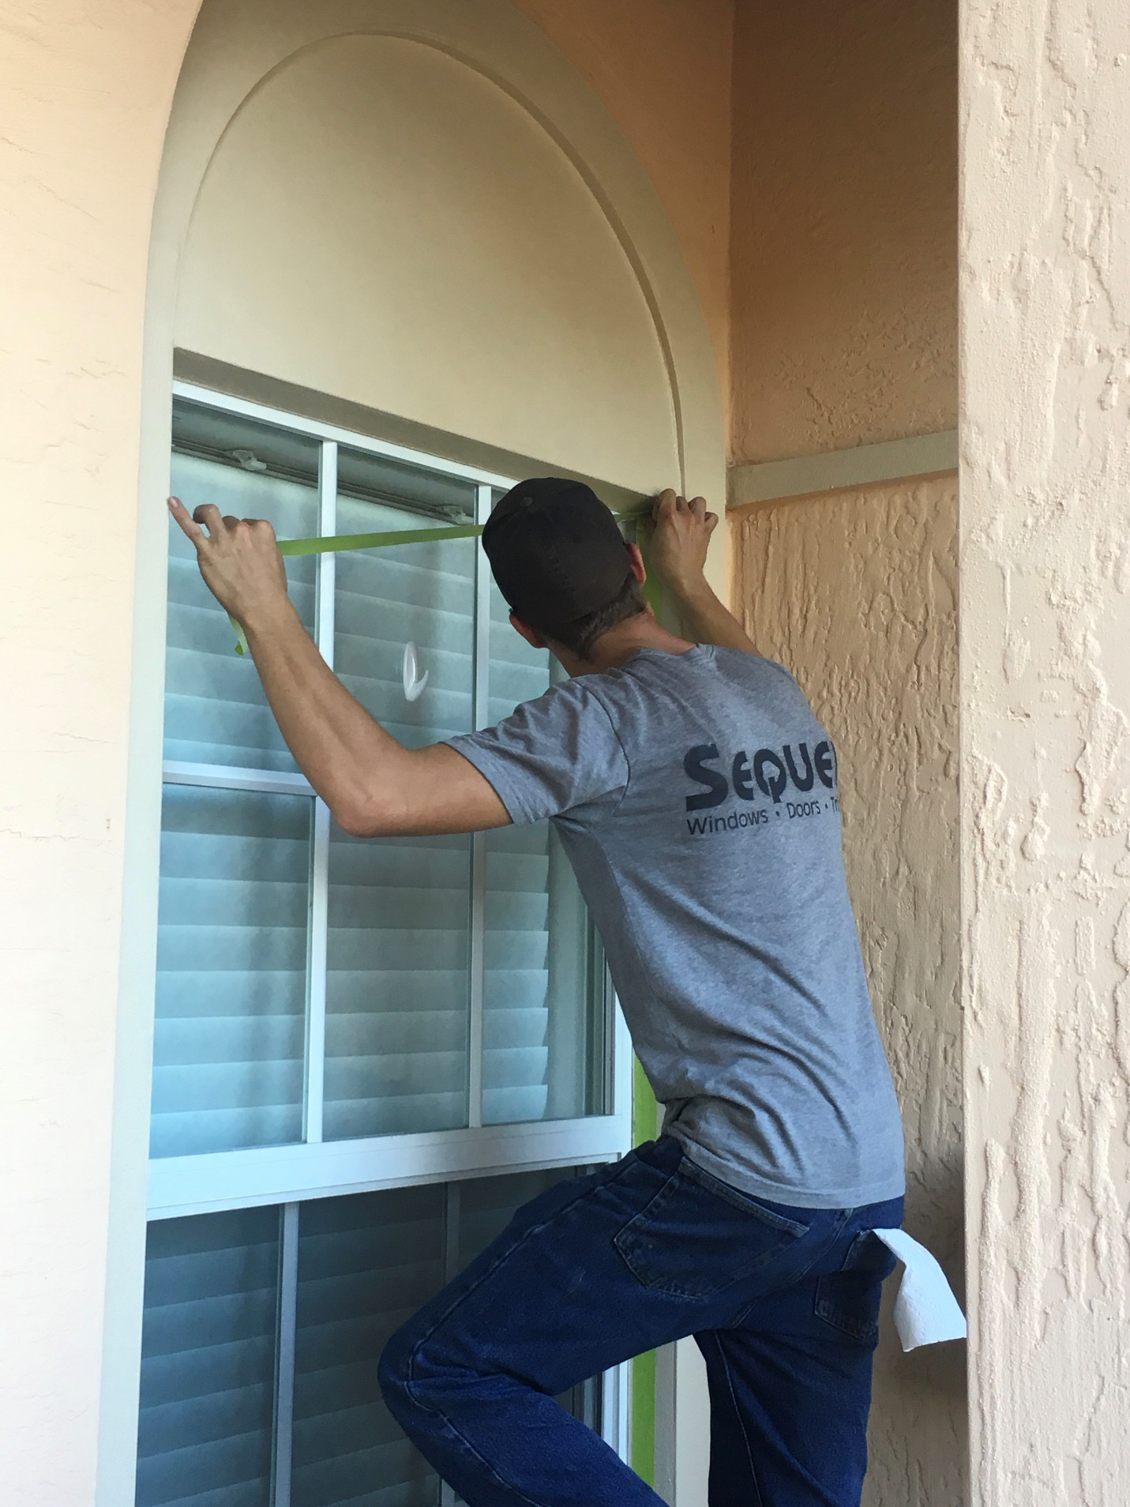

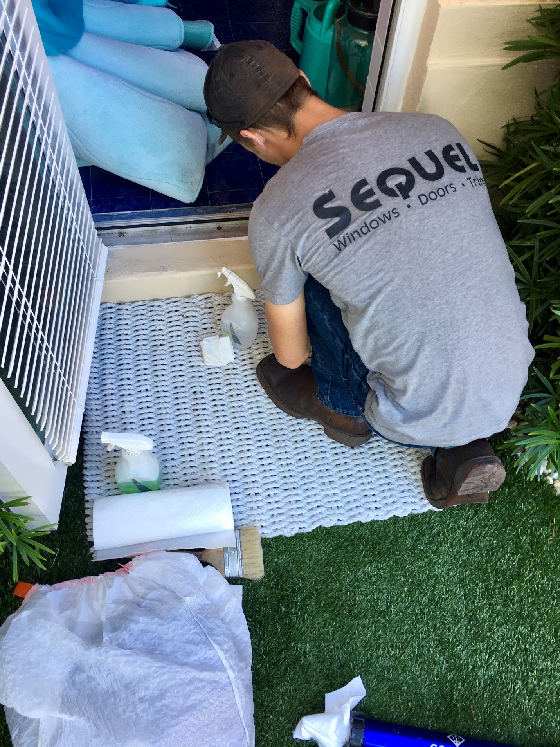

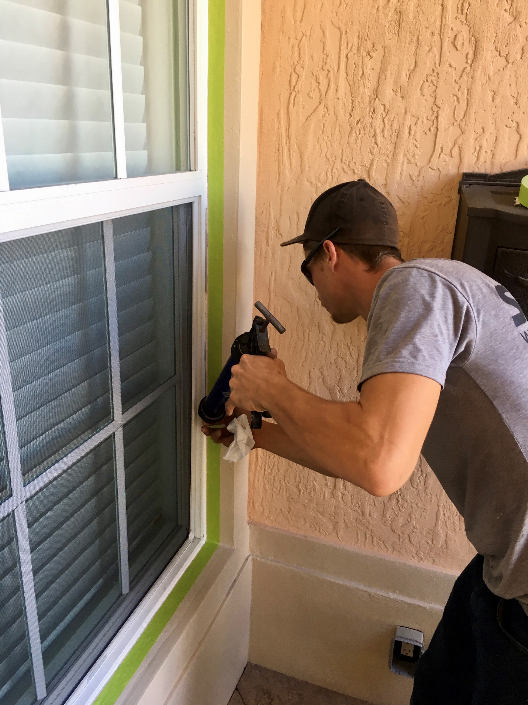

At the end and the back of the booklet we can add extra pictures of the installations we have done. The steps don’t need to be separated, they just need to have the pics.

